Jenkins Sonar And Argo CD Doc

Create an ec2 instance t2.xlarge

Connect ec2 with ssh from local

Installations

**Maven**

sudo yum update

sudo yum install -y maven

mvn -version

**Now Install open jdk 11**

sudo yum install java-11-amazon-corretto-headless

**Now Install Docker**

sudo yum update -y

sudo yum install -y docker

sudo service docker start

sudo chkconfig docker on - This command configures the Docker service to start automatically on system boot

Overall, these commands update the system, install Docker, start the Docker service, and set it to automatically start on system boot, allowing you to work with Docker and run containerized applications on your Linux system.

**Now install Jenkins**

sudo wget -O /etc/yum.repos.d/jenkins.repo \

https://pkg.jenkins.io/redhat-stable/jenkins.repo

sudo rpm --import https://pkg.jenkins.io/redhat-stable/jenkins.io-2023.key

sudo yum install jenkins -y

sudo systemctl enable jenkins

sudo systemctl start jenkins

yum update -y yum.noarch

**Install Node**

**curl -o- https://raw.githubusercontent.com/nvm-sh/nvm/v0.39.3/install.sh | bash**

**. ~/.nvm/nvm.sh**

**nvm install 16**

**Verification:**

**node -e "console.log('Running Node.js ' + process.version)"**

**Install Git**

sudo yum install -y git

**Add following things in security grp**

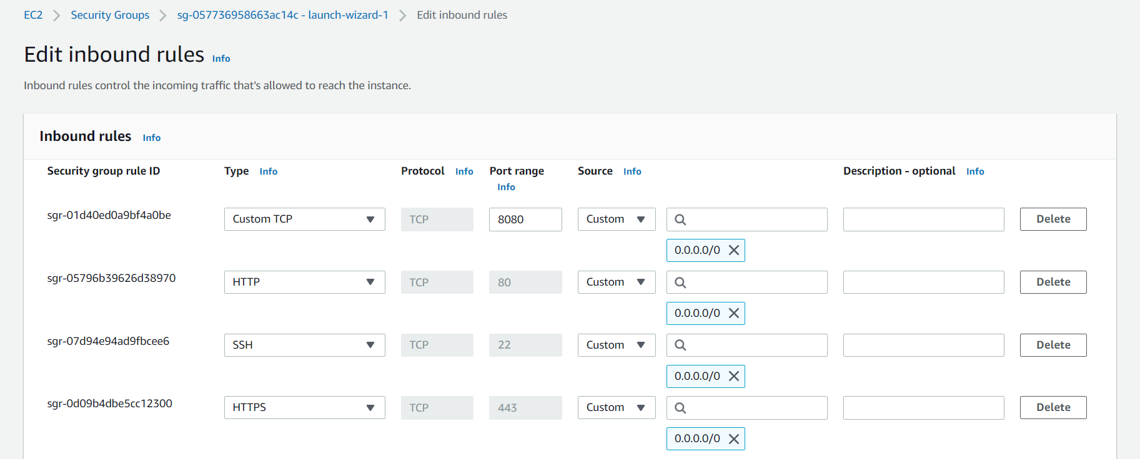

**To check the status of jenkins**

sudo systemctl status jenkins

**After this get password from below command in jenkins**

sudo cat /var/lib/jenkins/secrets/initialAdminPassword

**After Jenkins installation add ssh plugin**

Manage jenkins - plugin

* Available plugin - [SSH Agent](https://plugins.jenkins.io/ssh-agent) - install without restart
* Manage jenkins - tools- Add Maven

**To integrate webhook in jenkins**

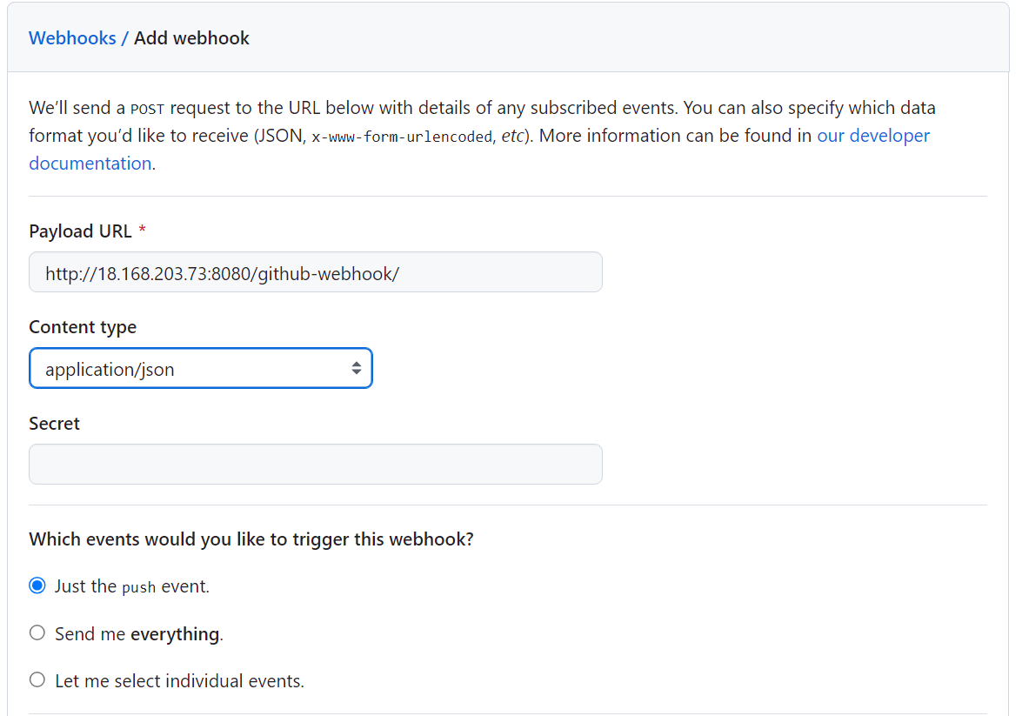

Create ssh key in jenkins server using command

ssh-keygen -t rsa -b 4096

Command to fetch public key -

cat ~/.ssh/id_rsa.pub

Command to fetch private key -

cat ~/.ssh/id_rsa

**Add this public key in git hub . go to setting go to ssh key and add new key**

Add private key in jenkins now

Go to jenkins - manage jenkins - credentials - Add ssh username with private key

Add docker creds - username with password

Codedecode25

DOCKER_HUB_CREDENTIAL - id

Also add this no verification which will be used during git push

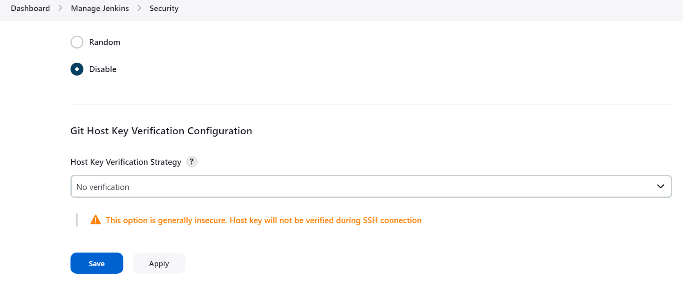

Go to jenkins home. Click new item. Click on pipeline. Copy Restaurant Service Http clone url

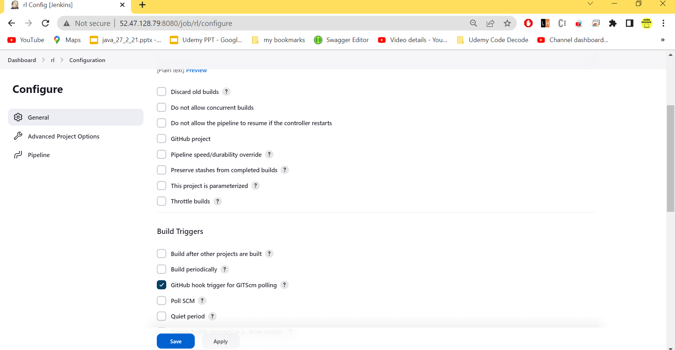

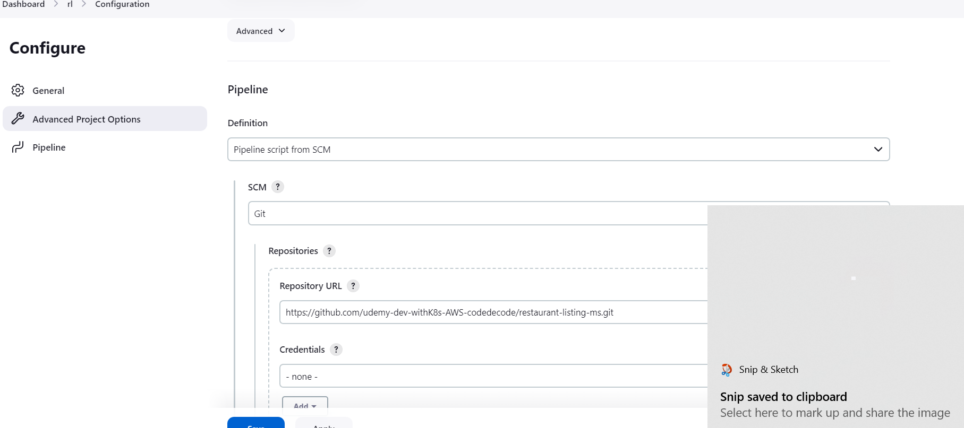

sav e n add dummy commit build automatically triggers

Nowcheck manifest file

To provide access to docker

sudo usermod -aG docker jenkins

Restart jenkins after that

sudo service jenkins restart

Sonar

**Run Sonar in docker using below command**

docker run -d -p 9000:9000 --name sonarqube sonarqube

**To check the logs**

docker logs -f sonarqube

**Hit**

15.188.80.32:9000 for sonar dashboard and username password will be admin

**To generate token go to sonar dashboard**  
Click on user icon - my account - security and create new token

**Quality GAtes**

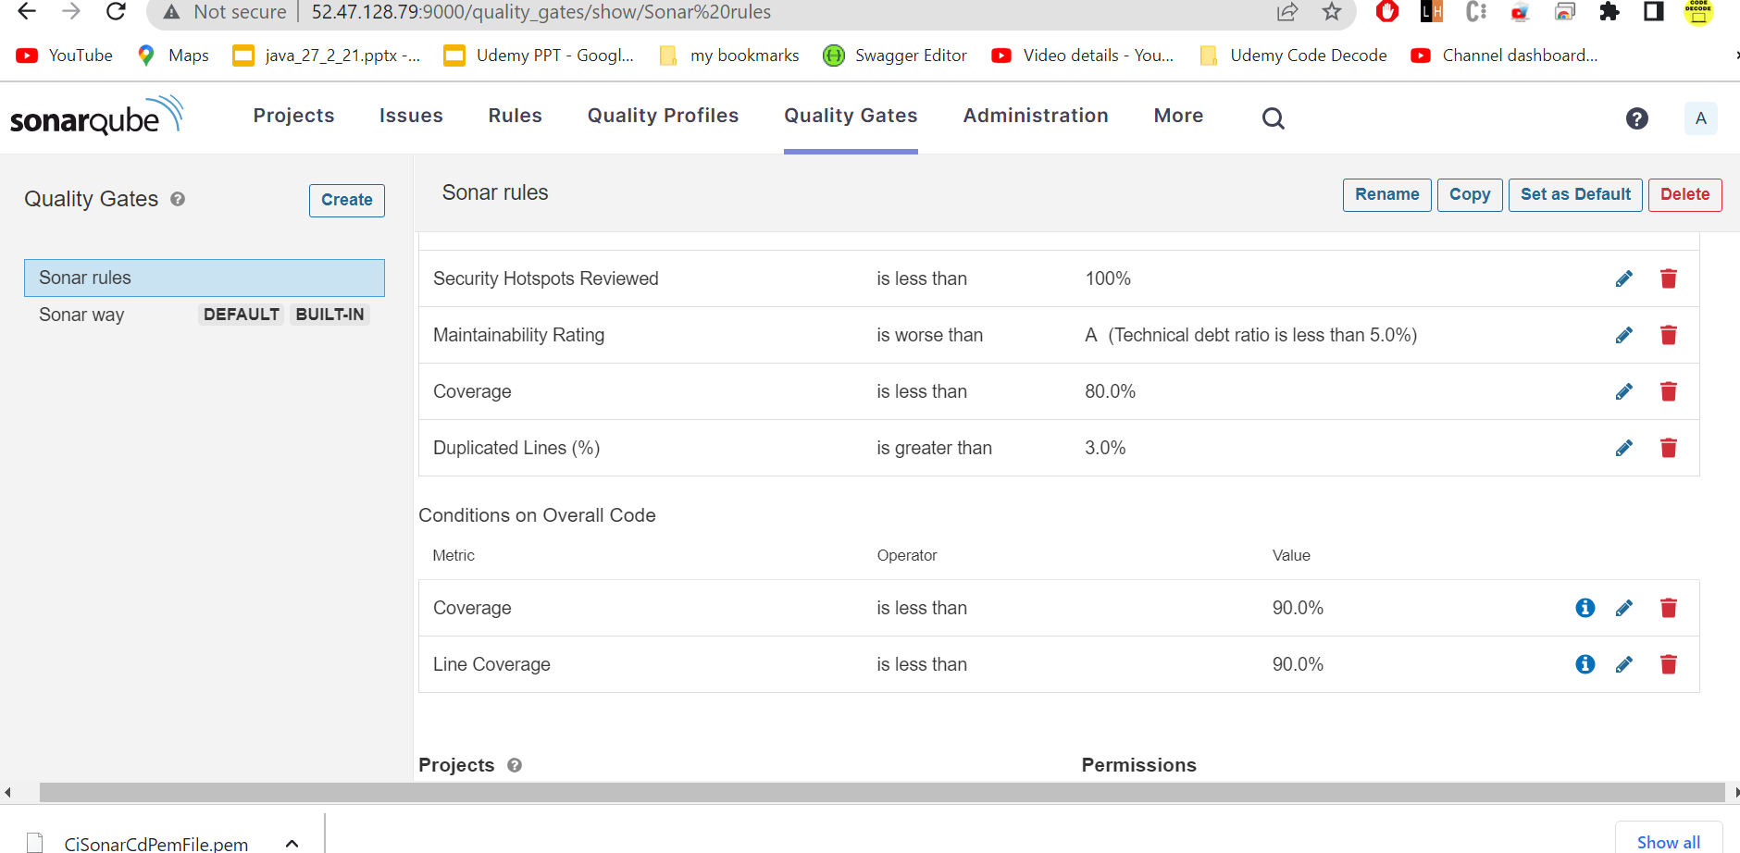

**To run sonar in local n push report in sonar dashboard**

mvn clean org.jacoco:jacoco-maven-plugin:prepare-agent install sonar:sonar -Dsonar.host.url=http://15.188.80.32:9000/ -Dsonar.login=squ_32789bcdadb6e4337e432d6cbc100c2a1a14fde5

**Now put following dependencies in pom**

<**plugin**>

<**groupId**>org.apache.maven.plugins</**groupId**>

<**artifactId**>maven-compiler-plugin</**artifactId**>

<**configuration**>

<**source**>1.8</**source**>

<**target**>1.8</**target**>

<**annotationProcessorPaths**>

<**path**>

<**groupId**>org.projectlombok</**groupId**>

<**artifactId**>lombok</**artifactId**>

<**version**>1.18.26</**version**>

</**path**>

<**path**>

<**groupId**>org.mapstruct</**groupId**>

<**artifactId**>mapstruct-processor</**artifactId**>

<**version**>1.4.2.Final</**version**>

</**path**>

</**annotationProcessorPaths**>

</**configuration**>

</**plugin**>

<**plugin**>

<**groupId**>org.sonarsource.scanner.maven</**groupId**>

<**artifactId**>sonar-maven-plugin</**artifactId**>

<**version**>3.8.0.2131</**version**>

</**plugin**>

<**plugin**>

<**groupId**>org.jacoco</**groupId**>

<**artifactId**>jacoco-maven-plugin</**artifactId**>

<**version**>0.8.8</**version**>

<**executions**>

<**execution**>

<**id**>prepare-agent</**id**>

<**goals**>

<**goal**>prepare-agent</**goal**>

</**goals**>

</**execution**>

<**execution**>

<**id**>report</**id**>

<**goals**>

<**goal**>report</**goal**>

</**goals**>

</**execution**>

</**executions**>

</**plugin**>

**Add this command in properties**

<**sonar.exclusions**>**/com/codeddecode/restaurantlisting/dto/** , **/*/com/codeddecode/restaurantlisting/entity/**/*</**sonar.exclusions**>

**To generate token go to sonar dashboard**  
Click on user icon - my account - security and create new token

**Where to get component key**

Click on project – project setting – update key

Here you will find component key

<groupId>:<artifactId>

**Run sonar using below command**mvn clean org.jacoco:jacoco-maven-plugin:prepare-agent install sonar:sonar -Dsonar.host.url=http://localhost:9000/ -Dsonar.login=squ_a44ef243148d9f75cb3248851df2d555d5342ee2

After this delryr ptpject

Argo CD

Command to install argo cd in cluster

kubectl create namespace argocd

kubectl apply -n argocd -f https://raw.githubusercontent.com/argoproj/argo-cd/stable/manifests/install.yaml

kubectl port-forward svc/argocd-server -n argocd 8080:80

To Get the password

Initial username

argocd admin initial-password -n argocd

To install argocd cli  
choco install argocd-cli

Create ssh key in jenkins server using command

ssh-keygen -t rsa -b 4096

Command to fetch public key -

cat ~/.ssh/id_rsa.pub

Command to fetch private key -

cat ~/.ssh/id_rsa

To delete argocd completely

kubectl delete -n argocd -f <https://raw.githubusercontent.com/argoproj/argo-cd/stable/manifests/install.yaml>

If pods are in terminating state

kubectl delete pods --all -n argocd --grace-period=0 --force

Go to setting - repository - connect repo

Overall, the provided YAML describes an Argo CD "Application" resource that deploys application resources from a Git repository, with specific configuration options for the Argo CD Image Updater and synchronization behavior.